Teacher reference — not part of the student site
Syllabus QR Code & Canvas Embed Codes
IB Language & Literature HL · Celebration High School · 2026–2028
The link
https://acsuarez84.github.io/CHS-HL-English-26-27-Syllabus/
QR codes
Both point at the syllabus home page and use the highest error-correction level, so they still scan after photocopying, or with a small logo placed in the centre.
Scan one with your phone before printing a class set. Thirty seconds now saves a wall of posters that do not work.
For screen — slides, Canvas pages
600 × 600 px
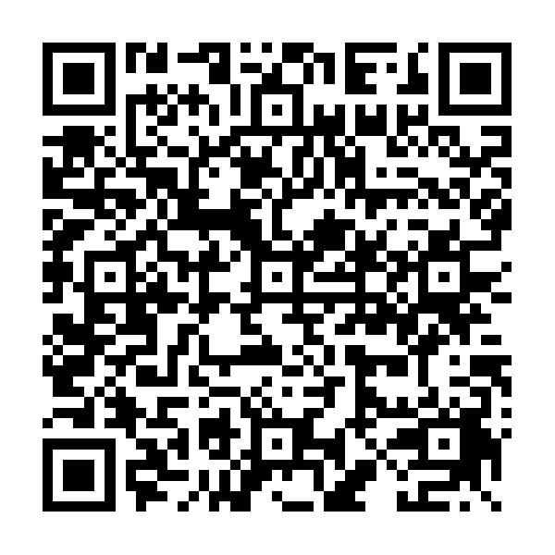
File: docs/teacher/syllabus-qr.png
For print — handouts, posters, the classroom wall
1000 × 1000 px
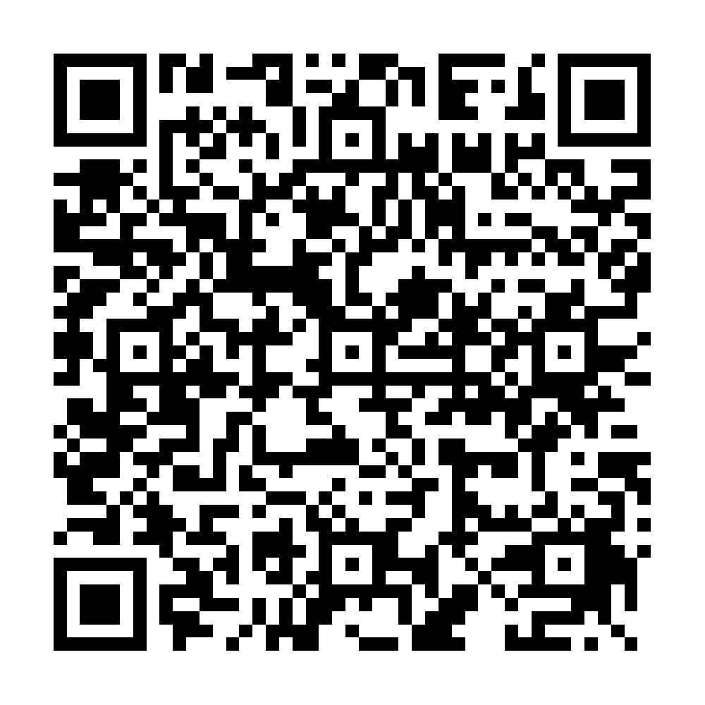
File: docs/teacher/syllabus-qr-print.png

Putting it in Canvas
Open the page in Canvas, click the HTML Editor button ( </> ) in the Rich Content Editor, and paste one of the blocks below.
The frame looks empty while you are editing. Canvas only draws it once you save and view the page — that is normal.
1 · Embed the whole syllabus
<iframe src="https://acsuarez84.github.io/CHS-HL-English-26-27-Syllabus/"
title="IB Language and Literature HL Syllabus"
width="100%" height="900"
style="border:1px solid #ccc; border-radius:8px;"
allowfullscreen></iframe>

2 · Embed a single section
Swap policy.html for any filename from the table below.
<iframe src="https://acsuarez84.github.io/CHS-HL-English-26-27-Syllabus/policy.html"
title="Course Policies"
width="100%" height="900"
style="border:1px solid #ccc; border-radius:8px;"></iframe>

3 · Link and QR card, no frame
Use this on a Canvas home page, or if the district blocks embedded frames. Upload the QR image to Canvas Files first, then insert it where the placeholder line sits.
<div style="text-align:center; padding:1.5em; border:2px solid #1F4E79;
border-radius:12px; max-width:520px; margin:1em auto;">
<h2 style="margin:0 0 .3em; color:#1F4E79;">IB Language &amp; Literature HL</h2>
<p style="margin:0 0 1em; color:#555;">Two-Year Course Outline &middot; 2026-2028</p>
<p><a href="https://acsuarez84.github.io/CHS-HL-English-26-27-Syllabus/" target="_blank" rel="noopener"
style="display:inline-block; background:#1F4E79; color:#fff;
padding:.7em 1.6em; border-radius:999px;
text-decoration:none; font-weight:bold;">Open the Syllabus</a></p>
<p>[ insert the QR image here from Canvas Files ]</p>
<p style="font-size:.85em; color:#666;">Scan with a phone camera</p>
</div>

Filenames for each section
Section | Filename
Syllabus home | index.html
The Six Literary Works | works.html
Non-Literary Texts | nonliterary.html
Concepts & Global Issues | concepts.html
Question Banks | questions.html
Year 1 — 2026–27 | year1.html
Year 2 — 2027–28 | year2.html
Assessments | assessments.html
Course Policies | policy.html
Citations | citations.html

It updates itself.
The site republishes whenever the syllabus changes, so anything embedded in Canvas stays current. The code never has to be pasted again.

